See Facebook page

**Zentangle101 by ekleberry**

**How to Zentangle**

1 - Use thin & medium permanent markers.

2 - Tape master onto hard, smooth surface.



3 - Add thick lines to “section” illustration.

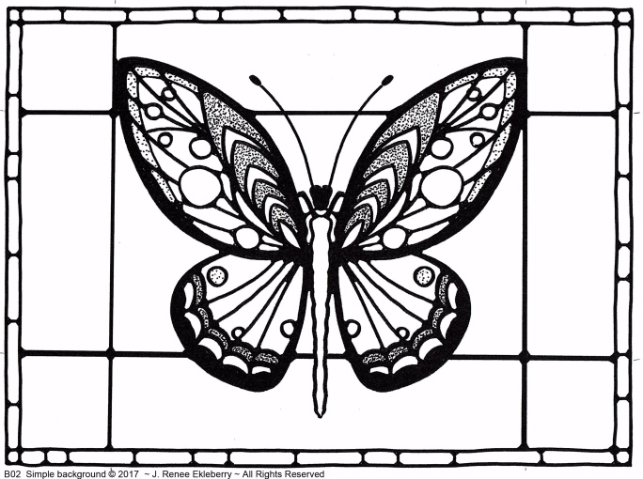

4 - Add “sectioning” lines w/ permanent marker.

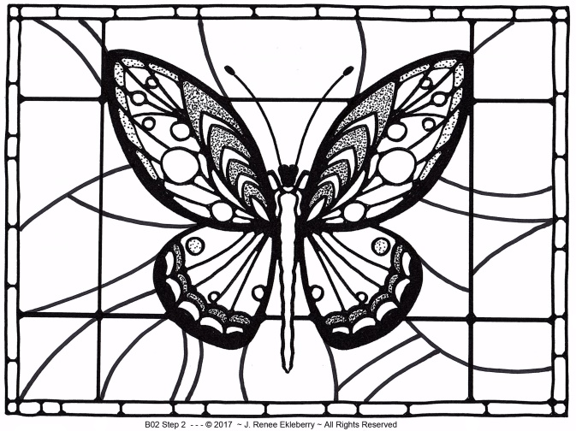

**5 -** “Zentangle” section by section working from the INSIDE to the OUTSIDE

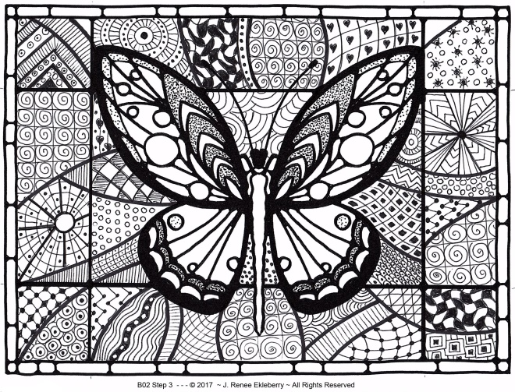

**OPTIONAL –COLORIZE YOUR DESIGN**

6 - Watercolor, Color Pencil, Color Marker

**See samples on ekleberry.com**

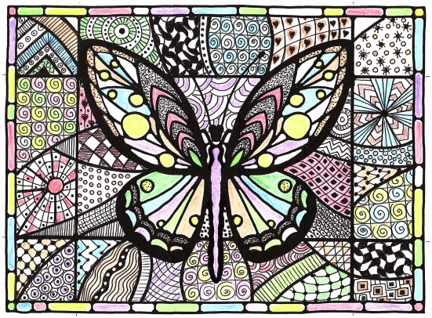

Sample – Color Pencil

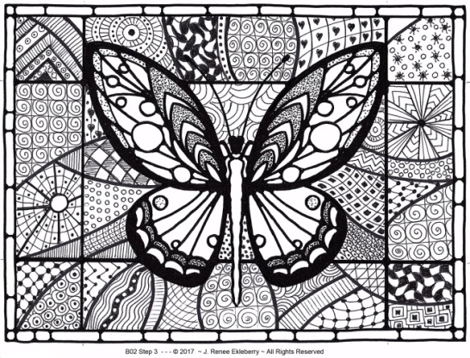

TO COME – Sample - Color Markers

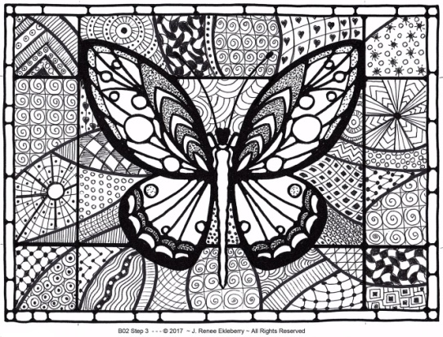

TO COME - Sample – Waatercolor

**___________________________________**ORDER “Master” sheets with center image for YOU to Zentangle or have a great

fun Zentangle party!

**www.ekleberry.com**